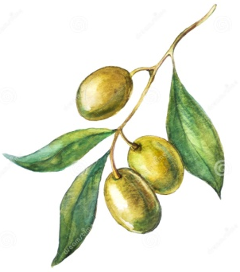
Ferguson's Delicatessen Christmas Order Form
Name: | Address:
Tel Number: |  | Date Required:
Email address:

Cheeses
Quantity | Product | Internal Use only. Unit price per 100g | Total

Meats
Quantity | Product | Internal Use only. Unit price per 100g | Total
48 High Street, Hadleigh, IP75AL. 01473B 824665. www.fergusonsdelicatessen.co.uk
Deli Counter
Quantity | Product | Internal Use only. Unit price per 100g | Total

